Annual report on patient representative group – now renamed Voice It! 2013-2014

Since the beginning of this DES in 2011 the practice has encouraged its patients to become involved in the PRG. We have over thirty patients who have registered an interest in the group. These patients are invited to every meeting and sent the minutes after the meetings. They are also sent the results of the annual surveys and the action plans for comment. They are notified of CCG meetings held in public and they have been notified about the PRG events organised by the CCG.
The profile of the group includes different age groups and different ethnic backgrounds although our surgery profile is predominantly 16 to 50 years of age and of Asian ethnicity. Some groups are still under represented (young mums and patients with learning disabilities).
Patients were originally invited by post and website invitation and staff were asked to seek out proactive members of our practice list. Information about the group is now provided in the new patient packs, via the web site, via notice boards in the waiting area and in newsletters.
We have contacted local community venues including churches and mosques and offered to visit these and other groups to encourage more people to become involved in the group.
Five meetings have been held this year. Unfortunately one meeting had to be abandoned as no patients turned up on time and another meeting was attended by only one patient. However, we continue to try and engage with our population.
This year we had a visit from Max McLean, lay member of the CCG who discussed his role in patient engagement and encouraged members of our group to stay involved.
Our action plan (attached) for this year was sent out to all patients who had registered an interest in being involved in the group. One response was received.
There were two major topics of discussion throughout the year. The first was patients not attending appointments and not cancelling them. This obviously is a waste of clinician time – doctors, nurse practitioners, practice nurses and health care assistants are all affected by this. The second topic was how to get more patients involved in the group.
The practice has changed morning surgeries to open surgeries this year and this seems to be helping reduce DNA’s. However, we still have an unacceptable level of DNA’s for booked appointments. There were lots of suggestions from the group about how we could deal with these patients and they agreed that the practice should send letters to these patients warning them about their behaviour. They also suggested that the clinician who is next to see the patient after a DNA should discuss it with them at the beginning of the consultation. This will make patients aware that we are noticing what they’re doing and how they are possibly misusing the system and blocking other patients from having appointments. We remind patients about their appointments either by phone or by text message if they are registered for SMS messages. We are still trying to increase the number of patients registered for SMS as this frees up receptionist time from making the phone calls and can be more convenient for patients.
We have also discussed how to deal with patients who are verbally abusive to our reception staff. Unfortunately this is quite a common occurrence. The group agreed that these patients should also be warned about their behaviour by letter.
The group thought that patients may not understand what a patient representative group is and decided to rename the group and have some leaflets printed to advertise the group. The leaflet has now been available in the waiting area for a few months.
Members of the group have had some good ideas about inviting more people to the meetings but, because we have so few who turn up for meetings, all the work would fall on to the same people. This makes it difficult for these suggestions to be put in to practice.
The final meeting for the year was again attended by only one patient, with apologies from one other patient. How to interest more people was, again, the main topic of the evening.

Access to services at Valley View Surgery
The Practice is open from 8.30am to 6pm (8pm on Tuesdays) Monday to Friday. At 6pm each evening, including Tuesdays, the phones are put through to Local Care Direct to ensure that our patients can access medical advice or treatment.
Surgeries are provided morning and afternoon by the doctors, nurse practitioners, practice nurse, health care assistants and phlebotomists with extended access appointments provided by a doctor and nurse practitioner on Tuesday evenings.
In an attempt to alleviate the problem of DNA’s, on the 1 September 2013 we changed our appointments system. We now have open surgeries every morning. Patients who arrive between 8.30am and 9.30am will be seen by either a doctor or an advanced nurse practitioner. We still have pre-bookable appointments every afternoon with the doctors and ANP’s and some pre-bookable appointments in the mornings. On Tuesday evenings our extended hours are covered by the doctors and advanced nurse practitioner.
Our doctor on call deals with any telephone messages whilst the other doctor will have four telephone consultations.

The results of our 2012/2013 survey are shown below:
Number of Responses: 176

Information about you

1. Are you:
Male 36%
Female 63%
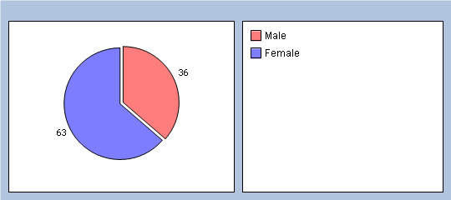

2. Please select your age group:
16-25 19%
26-35 30%
36-50 28%
51-65 12%
65 and over 7%
No response 4%
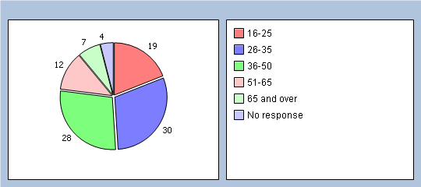

3. Please select your ethnic group:
Asian or Asian Black – Bangladeshi 9%
Asian or Asian Black – Indian 3%
Asian or Asian Black – other background 0%
Asian or Asian Black – Pakistani 57%
Black or Black British – Caribbean 0%
Black or Black British African 0%
Black or Black British – other background 0%
Mixed – Other background 0%
Mixed – White and Asian 2%
Mixed White 0%
and Black African 0%
Mixed – White and Black Caribbean 0%
Chinese 1%
White – British 22%
White Irish 1%
No response 5%
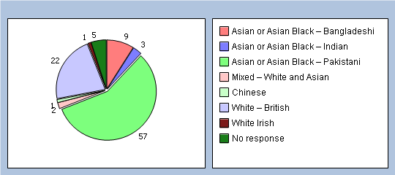

Access
Thinking of the times you have phoned the surgery, how would you rate the following.

4. How easy was it to get through to book an appointment?
Very easy 10%
Fairly easy 18%
Neither easy or difficult 21%
Fairly difficult 25%
Very difficult 22%
Don't know / never tried 0%
No response 4%
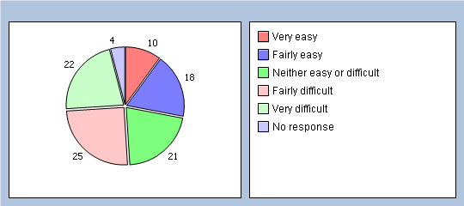

5. How easy was it to make an appointment with a doctor at the time you wanted?
Very easy 10%
Fairly easy 23%
Neither easy or difficult 18%
Fairly difficult 27%
Very difficult 16%
Don't know / never tried 1%
No response 5%
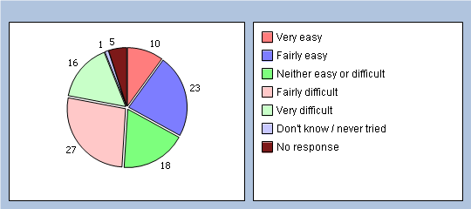

6. Are you able to see the doctor you wanted?
Never 5%
Sometimes 60%
Always 22%
Don't know / never tried 7%
No response 6%
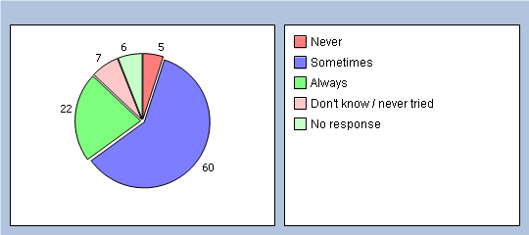

7. How important is it to you that you see the doctor of your choice when coming to the surgery?
Very important 55%
Fairly Important 27%
Not very important 3%
Not important 6%
Don't know 4%
No response 5%
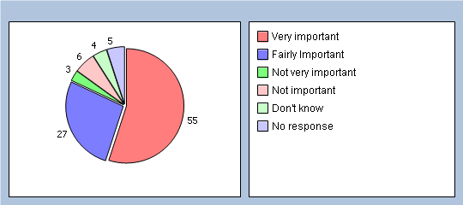

8. How long after your appointment time do you normally have to wait to be seen by the doctor or nurse?
5 minutes or less 25%
6-10 minutes 47%
11-20 minutes 19%
21-30 minutes 3%
More than 30 minutes 1%
No response 5%
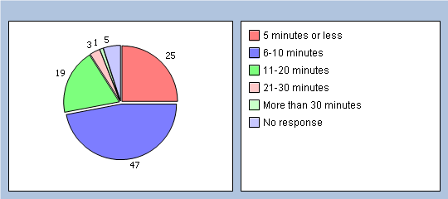

9. How do you feel about how long you normally have to wait?
I don't normally have to wait long 60%
I have to wait a bit too long 30%
I have to wait far too long 1%
No opinion / doesn't apply 5%
No response 4%
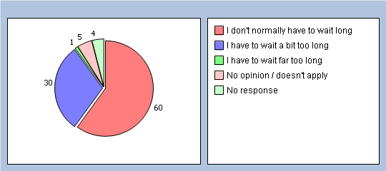

10. How do you feel about "telephone triage" (where a doctor/practitioner decides whether you need to be seen on the day)?
I would be satisfied 50%
I would not be satisfied 34%
Don't know / never used this service 14%
No response 2%
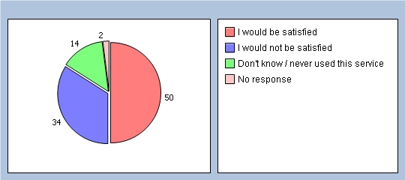

Reception

11. How helpful do you find our receptionists at the surgery?
Very helpful 55%
Fairly helpful 37%
Not very helpful 4%
Very unhelpful 1%
No opinion / doesn’t apply 1%
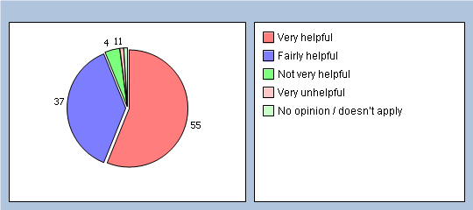

12. When you are in the reception area, can other patients hear what you say to the receptionists?
Yes 67%
No 31%
No response 2%
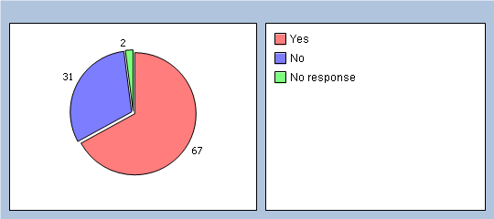

13. If you answered yes to the above question, how do you feel about this?
It doesn’t bother me 16%
It only happens sometimes / it’s not really a problem 24%
I ask to speak privately 13%
I feel uncomfortable as I don’t want anyone to hear 13%
I feel uncomfortable so I don’t explain what I need properly 7%
Other 10%
No response 17%
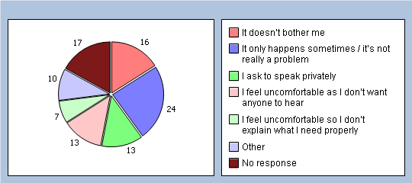

14. Do you feel that the new "wait here" sign has improved confidentiality in the reception area?
Yes 70%
No 26%
No response 4%
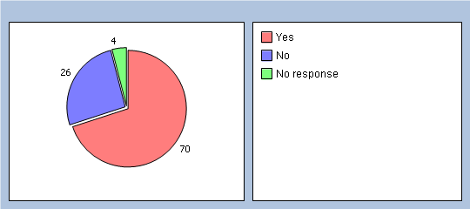

Patient Information

15. How easy is it to find out about the opening hours and services offered by our surgery?
Very easy 50%
Fairly easy 41%
Not very easy Not at all easy 4%
No response 5%
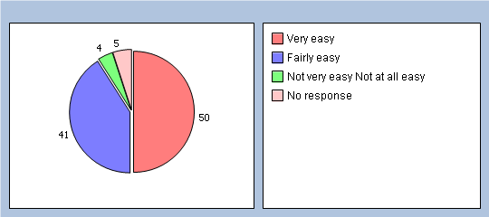

16. Are you aware of the surgery website and how to access it?
Yes 44%
No 53%
No response 3%
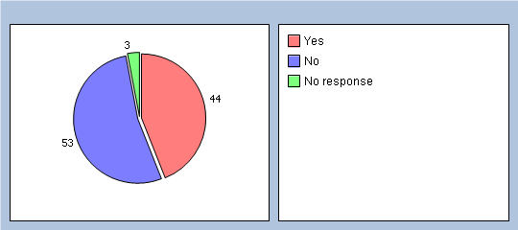
If you answered yes, is there any other information that you would like to see included?

Appointments

17. Sometimes patients arrive late for their appointments which is a problem because it has a knock on effect to other patients. Thinking about those patients who arrive late for their appointments, how do you think the surgery should deal with this issue?
See them on arrival as soon as it is convenient 35%
See them at the end of the surgery 35%
Ask them to make an alternative appointment if possible 22%
No response 8%
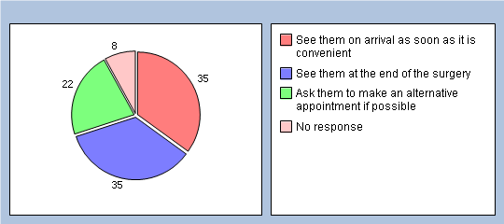

18. Following the results of last years survey, there is now a system in place where patients will not be seen if they attend 15 minutes or more late for their appointment. Up to 15 minutes late, patients may or may not be seen - at the discretion of the doctor or nurse their appointment is booked with. Do you think that this new system is:
Fair 86%
Not fair 9%
No response 5%
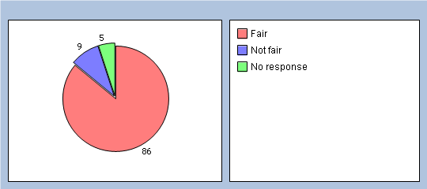

19. Missed appointments are a big problem for us as it wastes clinical time that could have been allocated to other patients. How would you like to see us tackle this problem?
Undertake a campaign to highlight how important it is to keep appointments 13%
Send appointment reminders via phone 58%
Write to inform them of the missed appointment and warn of the consequences i.e. removal from the list 23%
No response 6%
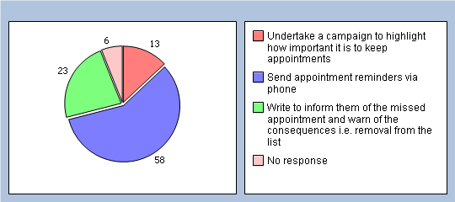

20. One of the ways we use to try to reduce the number of missed appointments is to remind patients about their routine appointments by phone and by text message to a mobile. How helpful do you / would you find this service?
Very helpful 81%
Fairly helpful 10%
Not very helpful 1%
Not helpful at all 0%
No opinion / doesn’t apply 2%
No response 6%
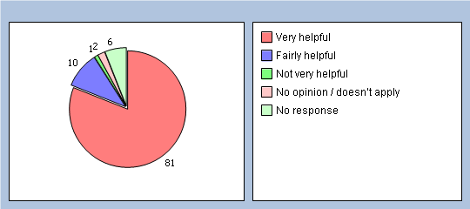
If you wish to receive text reminders please complete a form at the reception desk.

Prescriptions

21. How satisfied are you with our current system for asking for repeat prescriptions?
Very satisfied 42%
Fairly satisfied 39%
Not very satisfied 7%
Not satisfied at all 5%
No response 7%
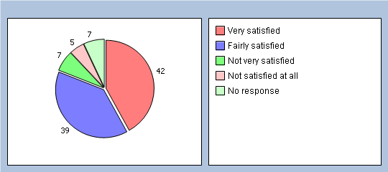

22. Are you aware that you can now order repeat prescriptions on the web site?
Yes 30%
No 66%
No response 4%
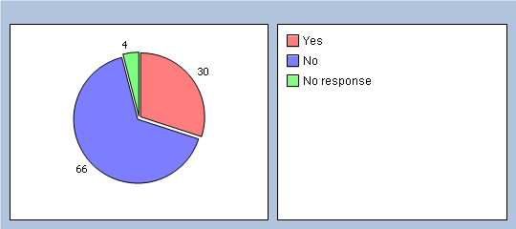

Other

23. How satisfied are you with the service you receive at the surgery?
Very satisfied 48%
Fairly satisfied 43%
Not very satisfied 5%
No response 4%
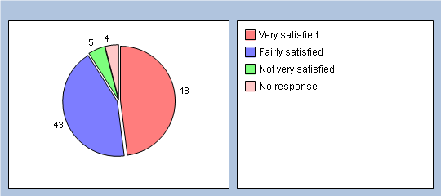

24. Would you recommend the surgery to someone who has just moved into the local area?
Yes 82%
No 13%
No response 5%
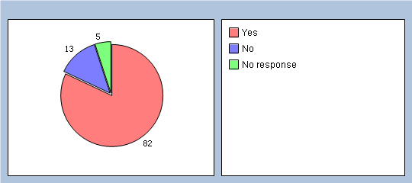
If no, please tell us why

Based on these results, the following action plan was formulated and sent out to all the patients who had registered an interest in the group.

Actions taken
- Although we gave the triage system a lot of thought, a change in clinical staff during the year gave us the opportunity to trial open surgeries. These seem to be working well and we hope to see an improvement in patient satisfaction in this year’s annual survey.
- We continue to inform patients about our web site and staff are regularly reminded to ask about SMS messaging and choice of pharmacist.
- We now have more regular staff meetings with reminders and advice/discussions about any problems which may have arisen. The open surgeries also seem to have eased any real or perceived tensions which patients may have felt they had with our receptionists.

A member of practice staff has attended two patient engagement events and we will continue to be involved with these groups to try and find different ways to get our patients involved.

DNA’s per month which is approximately 30-35 hours of doctor/nurse time wasted. The group agreed that these patients should receive letters warning them about their behaviour as should patients who are verbally abusive to staff. Unfortunately this is something which our receptionists deal with every day.

- Some members of the group were unaware that the practice has a web site. This is advertised on the call screen in the waiting area. It’s also advertised in the practice leaflet and the newsletter and on various notice boards around the practice. We obviously need to do more to make this more widely known.

- Mr Shah thanked Max for attending and for his contribution to the meeting.

The next meeting will be held on Tuesday 30 July at 6pm in the health education room.

- When the new appointment system has been running for a few weeks we will try to breakdown the open appointments to show age groups and problems.

- The next meeting will be on Tuesday 29 October at 6pm in the health education room.

The results of this year’s survey are shown below. They will be discussed at the next meeting of the group.
Top of Form
Valley View Surgery
Valley View Surgery Patient Survey 2013-2014
Number of Responses: 209

Valley View Surgery Patient Questionnaire 2013-2014
Are you
Male 37%
Female 61%
No response 2%
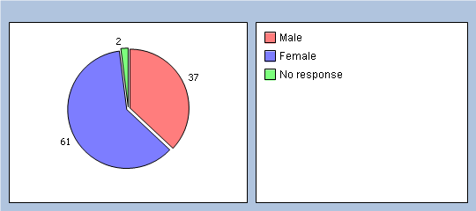
Please select age group
16-25 18%
26-35 35%
36-50 29%
51-65 11%
65 and over 5%
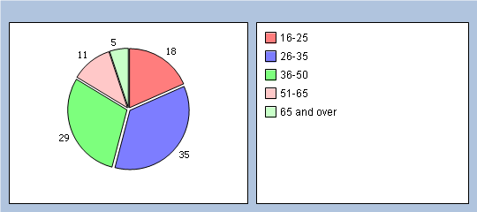
Are you aware that we now have open access surgeries every morning between 8.30am and 9.30am?
Yes 87%
No 12%
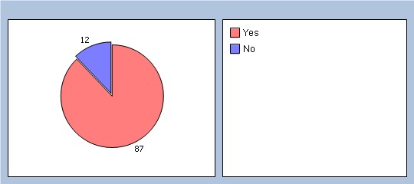
Has the open surgery made it easier to see a doctor?
Yes 71%
No 23%
No response 6%
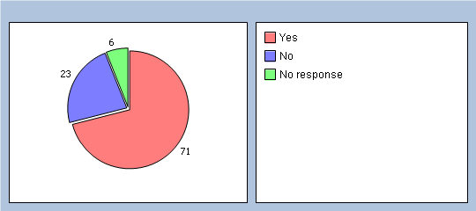
Do you find the booking in screen easy to use?
Yes 79%
No 16%
No response 5%
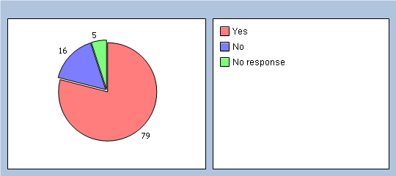
If the open surgery is busy are you prepared to attend on a different day?
Yes 73%
No 24%
No response 3%
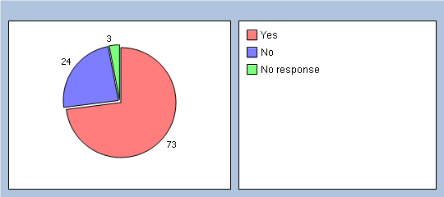
Do you think that our mix of open surgeries in the morning and bookable appointments in the afternoons works well?
Yes 76%
No 20%
No response 4%
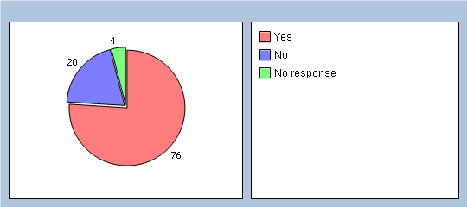
If you answered No to the last question please comment
How easy was it to get through on the phones to book an appointment?
Very Easy 13%
Easy 42%
Difficult 25%
Very Difficult 15%
No response 5%
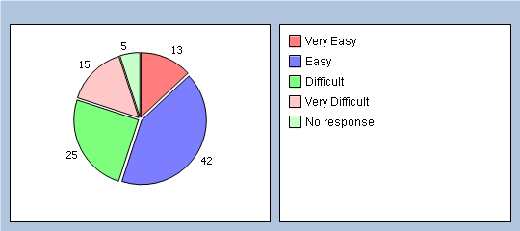
How easy was it to make an appointment with a doctor at the time you wanted?
Very Easy 11%
Easy 32%
Difficult 36%
Very Difficult 17%
No response 4%
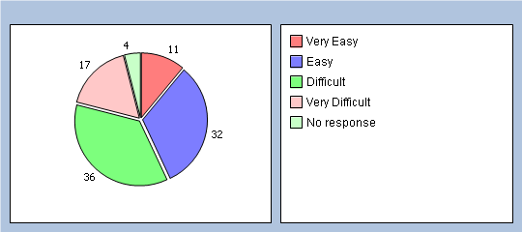
Are you able to see the doctor you want?
Yes 55%
No 39%
No response 6%
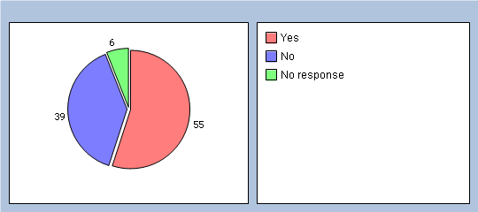
How important is it to you that you see the doctor of your choice when coming to surgery?
Very Important 53%
Important 32%
Not Important 11%
No response 4%
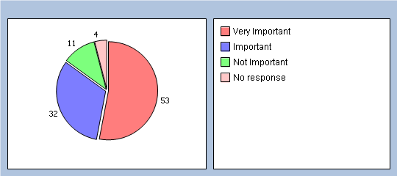
How helpful do you find our receptionists?
Very Helpful 41%
Helpful 53%
Not at all Helpful 3%
No response 3%
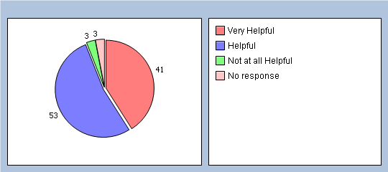
When you are in the reception area, can other patients hear what you say to the receptionist?
Yes 66%
No 31%
No response 3%
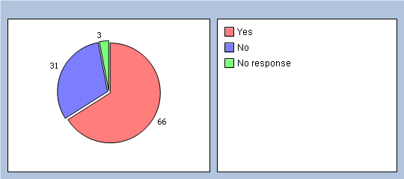
If you answered Yes to the last question, how do you feel about this?
Are you aware of the surgery website and how to access it?
Yes 39%
No 55%
No response 6%
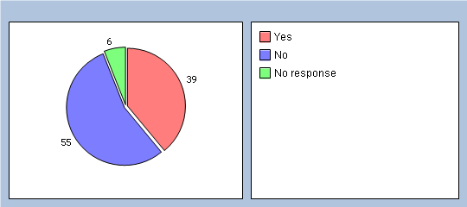
How easy is it to find out about the opening hours and services offered by our surgery?
Very Easy 26%
Easy 57%
Difficult 7%
Very Difficult 4%
No response 6%
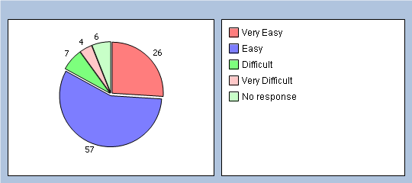
Are you aware that you can order prescriptions on the website?
Yes 28%
No 66%
No response 6%
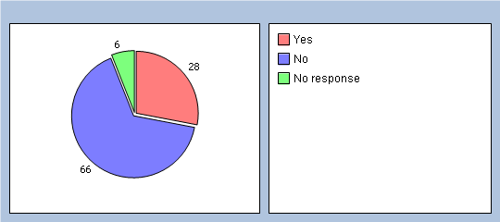
Are you interested in joining the patient representative group (Voice It!) to work with the practice to improve services? If you answer yes, please ask for a contact form at reception.
Yes 11%
No 82%
No response 7%
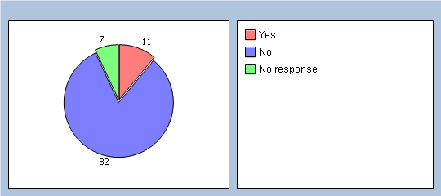
Are you aware that you can also get information about services available from the NHS Choices website at www.nhs.uk
Yes 51%
No 42%
No response 7%
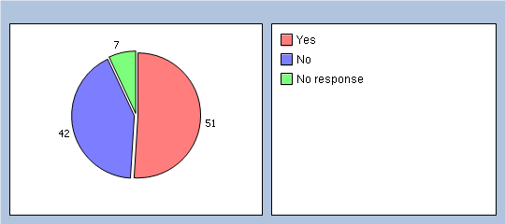
How satisfied are you with the service you receive at the surgery?
Very Satisfied 32%
Satisfied 55%
Not at all Satisfied 8%
No response 5%
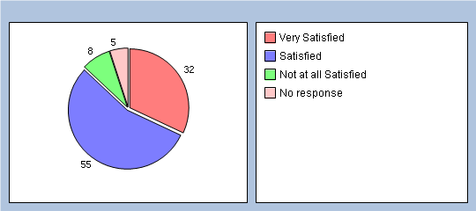
Would you recommend the surgery to someone who has just moved in to the local area?
Yes 77%
No 16%
No response 7%
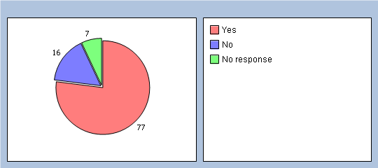
If you answered No to the last question, please tell us why.
Please select your ethnic group
Asian or Asian Black – Bangladeshi 7%
Asian or Asian Black – Indian 3%
Asian or Asian Black – other background 1%
Asian or Asian Black – Pakistani 58%
Black or Black British – Caribbean 0%
Black or Black British African 0%
Black or Black British – Other Background 0%
Mixed – Other Background 0%
Mixed – White and Asian 1%
Mixed White and Black African 0%
Mixed – White and Black Caribbean 0%
Chinese 0%
White – British 17%
White Irish 0%
Other 5%
No response 8%
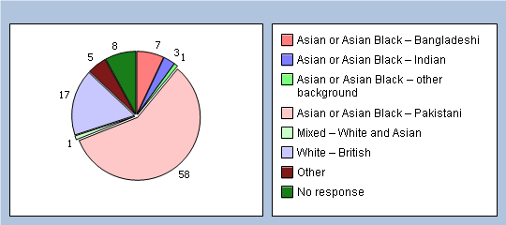

Bottom of Form

